数据分析报告 2002-06-25 - 2019-05-23 (4087 days)

# 1、警告信息（Warning）

2003-01-29 到下一个交易日间存在 12 天没有行情数据，可能存在数据遗漏  
2003-04-30 到下一个交易日间存在 12 天没有行情数据，可能存在数据遗漏  
2004-01-16 到下一个交易日间存在 13 天没有行情数据，可能存在数据遗漏  
2005-02-04 到下一个交易日间存在 12 天没有行情数据，可能存在数据遗漏  
2007-09-26 到下一个交易日间存在 12 天没有行情数据，可能存在数据遗漏

# 2、行情曲线

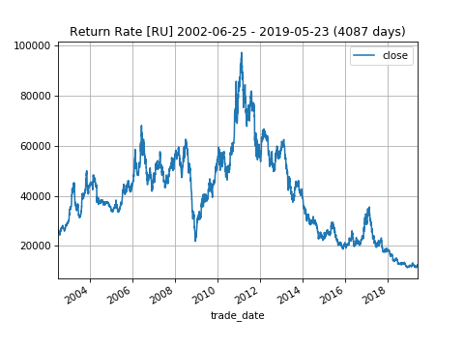

# 3、Histgram 分布图

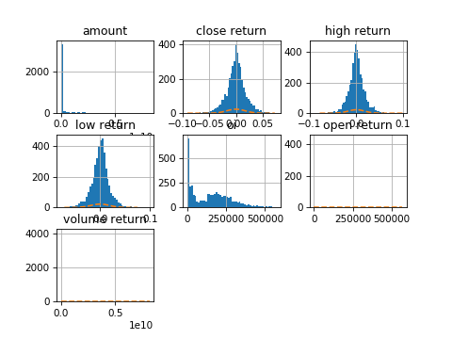

# 4、分位数信息（Quantile）

|  |  |  |  |  |  |
| --- | --- | --- | --- | --- | --- |
|  | **0.2** | **0.33** | **0.5** | **0.66** | **0.8** |
| **close rr** | -1.26% | -0.58% | 0.02% | 0.56% | 1.26% |

# 5、未来N日收益率最高最低值分布图

## 5.1) 未来 3 日 close 收益率最高最低值分布图

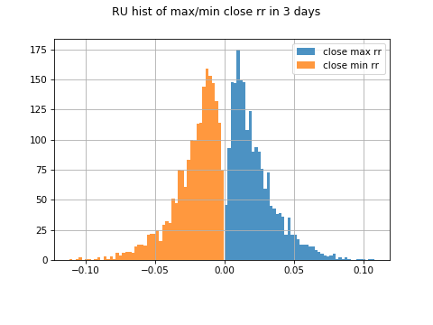

### 5.1.1) 分位数信息

|  |  |  |  |  |  |
| --- | --- | --- | --- | --- | --- |
|  | **0.2** | **0.33** | **0.5** | **0.66** | **0.8** |
| **close max rr** | 0.83% | 1.17% | 1.74% | 2.43% | 3.32% |
| **close min rr** | -3.34% | -2.53% | -1.79% | -1.24% | -0.85% |

### 5.1.2) 三分类标签分布比例

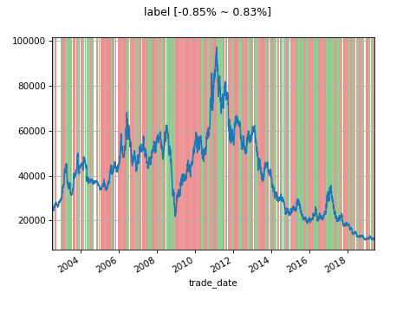

|  |  |  |  |
| --- | --- | --- | --- |
|  | **0** | **1 under -0.85%** | **2 over 0.83%** |
| **pct** | 9.69% | 44.60% | 45.71% |

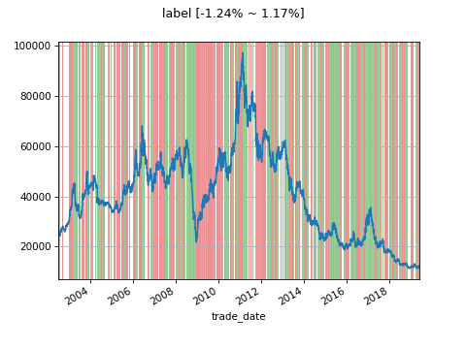

|  |  |  |  |
| --- | --- | --- | --- |
|  | **0** | **1 under -1.24%** | **2 over 1.17%** |
| **pct** | 19.40% | 39.76% | 40.84% |

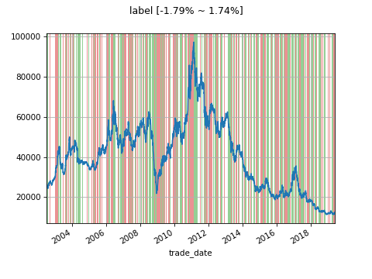

|  |  |  |  |
| --- | --- | --- | --- |
|  | **0** | **1 under -1.79%** | **2 over 1.74%** |
| **pct** | 34.87% | 32.96% | 32.18% |

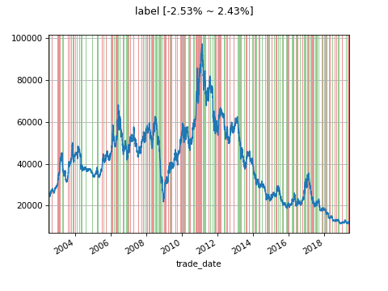

|  |  |  |  |
| --- | --- | --- | --- |
|  | **0** | **1 under -2.53%** | **2 over 2.43%** |
| **pct** | 52.39% | 23.44% | 24.17% |

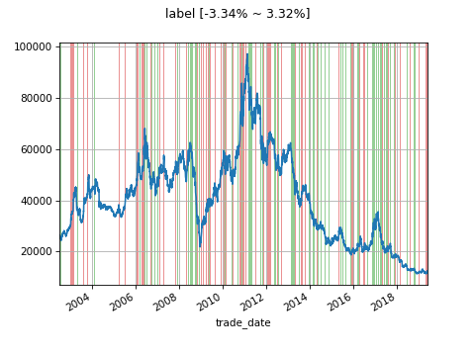

|  |  |  |  |
| --- | --- | --- | --- |
|  | **0** | **1 under -3.34%** | **2 over 3.32%** |
| **pct** | 68.29% | 15.81% | 15.90% |

## 5.2) 未来 5 日 close 收益率最高最低值分布图

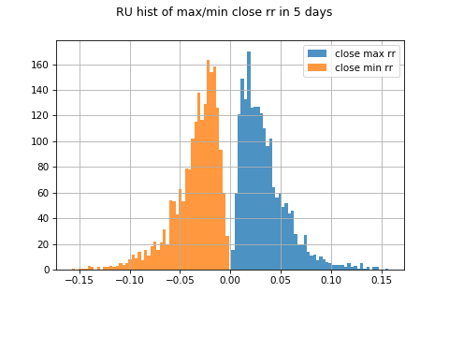

### 5.2.1) 分位数信息

|  |  |  |  |  |  |
| --- | --- | --- | --- | --- | --- |
|  | **0.2** | **0.33** | **0.5** | **0.66** | **0.8** |
| **close max rr** | 1.50% | 2.04% | 2.89% | 3.82% | 5.06% |
| **close min rr** | -5.06% | -3.85% | -2.95% | -2.19% | -1.59% |

### 5.2.2) 三分类标签分布比例

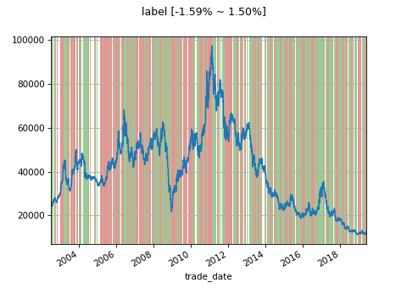

|  |  |  |  |
| --- | --- | --- | --- |
|  | **0** | **1 under -1.59%** | **2 over 1.50%** |
| **pct** | 13.46% | 43.33% | 43.21% |

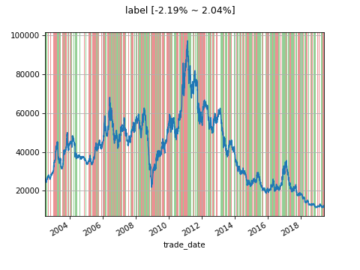

|  |  |  |  |
| --- | --- | --- | --- |
|  | **0** | **1 under -2.19%** | **2 over 2.04%** |
| **pct** | 25.23% | 37.02% | 37.75% |

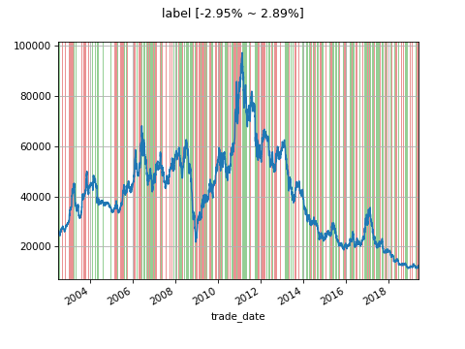

|  |  |  |  |
| --- | --- | --- | --- |
|  | **0** | **1 under -2.95%** | **2 over 2.89%** |
| **pct** | 41.91% | 29.12% | 28.97% |

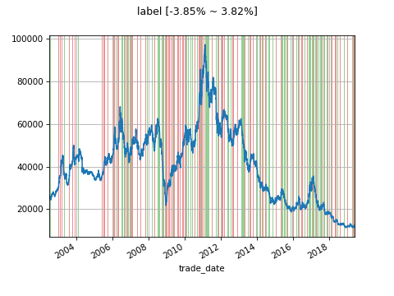

|  |  |  |  |
| --- | --- | --- | --- |
|  | **0** | **1 under -3.85%** | **2 over 3.82%** |
| **pct** | 58.60% | 20.82% | 20.58% |

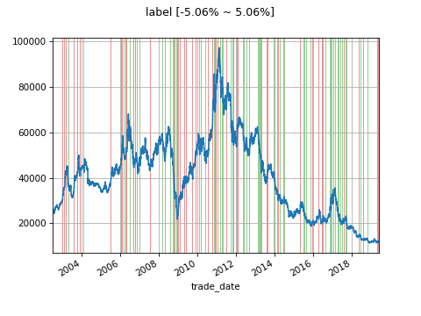

|  |  |  |  |
| --- | --- | --- | --- |
|  | **0** | **1 under -5.06%** | **2 over 5.06%** |
| **pct** | 73.28% | 13.48% | 13.24% |

# 6、行情回撤曲线

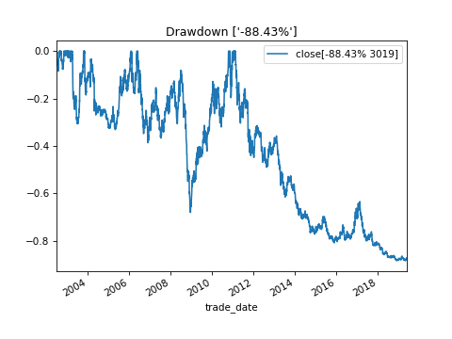

# 7、散点图矩阵图（Scatter Matrix）

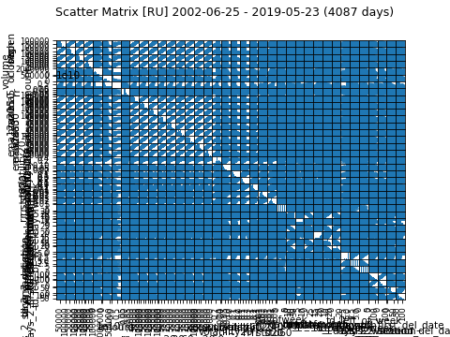

# 8、相关性矩阵图（Correlation）

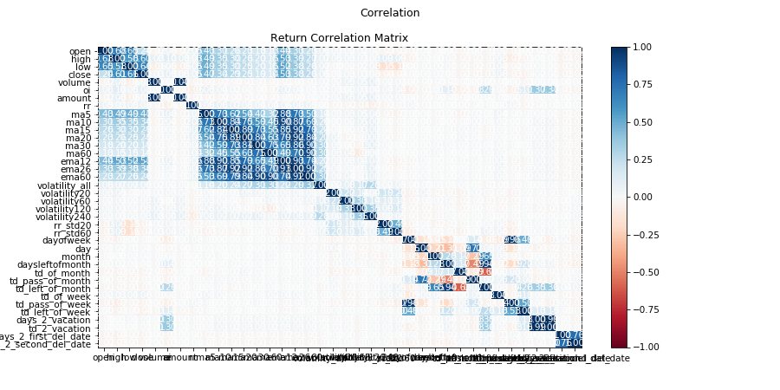

close 数据分析结果

# 1、分位数信息（Quantile）

|  |  |  |  |  |  |
| --- | --- | --- | --- | --- | --- |
|  | **0.25** | **0.33** | **0.5** | **0.66** | **0.75** |
| **close rr** | -0.98% | -0.58% | 0.02% | 0.56% | 0.97% |

# 2、Histgram 分布图

